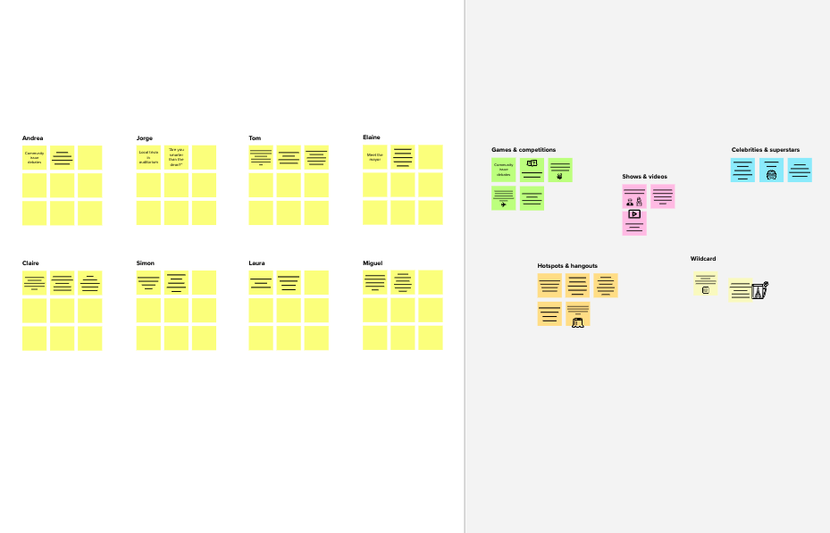

Large and accurate dataset is easy to predict the future stock needs.

Alert demand stock

Frequent analysis of data

Information of stocks sold

Prevents over stock

# Brainstorm

**TIP**

You can select a sticky note and hit the pencil [switch to sketch] icon to start drawing!

## Before you collaborate

A little bit of preparation goes a long way with this session. Here’s what you need to do to get going.

**10 minutes**

**1**

## Define your problem statement

What problem are you trying to solve? Frame your problem as a How Might We statement. This will be the focus of your brainstorm.

**5 minutes**

**2**

## Brainstorm

Write down any ideas that come to mind that address your problem statement.

**10 minutes**

**3**

## Group ideas

Take turns sharing your ideas while clustering similar or related notes as you go. In the last 10 minutes, give each cluster a sentence-like label. If a cluster is bigger than six sticky notes, try and see if you and break it up into smaller sub-groups.

**20 minutes**

**4**

## Prioritize

Your team should all be on the same page about what's important moving forward. Place your ideas on this grid to determine which ideas are important and which are feasible.

**20 minutes**

## After you collaborate

You can export the mural as an image or pdf to share with members of your company who might find it helpful.

**Quick add-ons**

# & idea prioritization

Use this template in your own brainstorming sessions so your team can unleash their imagination and start shaping concepts even if you're not sitting in the same room.

**10 minutes** to prepare

**1 hour** to collaborate

**2-8 people** recommended

1. **Team gathering**

Define who should participate in the session and send an invite. Share relevant information or pre-work ahead.

1. **Set the goal**

Think about the problem you'll be focusing on solving in the brainstorming session.

1. **Learn how to use the facilitation tools**

Use the Facilitation Superpowers to run a happy and productive session.

[**Open article**](https://support.mural.co/en/articles/2113740-facilitation-superpowers)

**PROBLEM**

**To predict and visualize the stock and sales inventory using visualization techniques in accurately**

## Key rules of brainstorming

To run an smooth and productive session

**Asliya Thahefa**

**TIP**

Add customizable tags to sticky notes to make it easier to find, browse, organize, and categorize important ideas as themes within your mural.

**Keerthana**

give detailed information about storage of stocks

Help the shop owners to maintain quality goos

Awareness campaigns on stocks

The supply on demand will be simplified

Spread awareness on stock wastage

**Geetha**

Future performance prediction

Providing centralized path to all customers

Strategic areas in data analysis for retailers

Identify the customers

Demand prediction

**Anitha**

Deliver proactive experience

Analyze the current Trends

Customer opinion is essential

Design information architecture

Create Feedback loops

DEMAND AND SUPPLY

Cost reduction with customer satisfaction

Only to update or place new orders

Proposing some ideas to develop the project

Always monitioring and updating the stock is essential

Spread awareness on stock wastage

Keep the things well organized will help in equal distribution and zero wastage

* 1. **Share the mural**

**Share a view link** to the mural with stakeholders to keep them in the loop about the outcomes of the session.

* 1. **Export the mural**

Export a copy of the mural as a PNG or PDF to attach to emails, include in slides, or save in your drive.

## Keep moving forward

**Strategy blueprint**

Define the components of a new idea or strategy.

[**Open the template**](https://app.mural.co/template/e95f612a-f72a-4772-bc48-545aaa04e0c9/984865a6-0a96-4472-a48d-47639307b3ca)

**Customer experience journey map**

Understand customer needs, motivations, and

Stay in topic. Defer judgment.

Encourage wild ideas. Listen to others.

Always monitoring and updating stocks

AWARENESS

## Importance

If each of these

Cost reduction with customer satisfaction

obstacles for an experience.

[**Open the template**](https://app.mural.co/template/b7114010-3a67-4d63-a51d-6f2cedc9633f/c1b465ab-57af-4624-8faf-ebb312edc0eb)

Go for volume. If possible, be visual.

Spread awareness on recycling on plastics

spread awareness on stock wastage

Fill every order retailers

create some app for develpment

MARKETING

tasks could get

done without any difficulty or cost, which would have the most positive impact?

**Strengths, weaknesses, opportunities & threats**

Identify strengths, weaknesses, opportunities, and threats (SWOT) to develop a plan.

|  |  |
| --- | --- |
|  |  |
|  |  |

[**Open the template**](https://app.mural.co/template/6a062671-89ee-4b76-9409-2603d8b098be/ca270343-1d54-4952-9d8c-fbc303ffd0f2)

**TIP**

Participants can use their cursors to point at where sticky notes should go on the grid. The facilitator can confirm the spot by using the laser pointer holding the **H key** on the keyboard.

[**Share template feedback**](https://muralco.typeform.com/to/CiqaHVat?typeform-source=app.mural.co)

[**Share template feedback**](https://muralco.typeform.com/to/CiqaHVat?typeform-source=app.mural.co)

## Feasibility

Regardless of their importance, which tasks are more feasible than others? (Cost, time, effort, complexity, etc.)

**Template**

**Need some inspiration?**

See a finished version of this template to kickstart your work.

[**Open example**](https://app.mural.co/template/e5a93b7b-49f2-48c9-afd7-a635d860eba6/93f1b98d-b2d2-4695-8e85-7e9c0d2fd9b9)